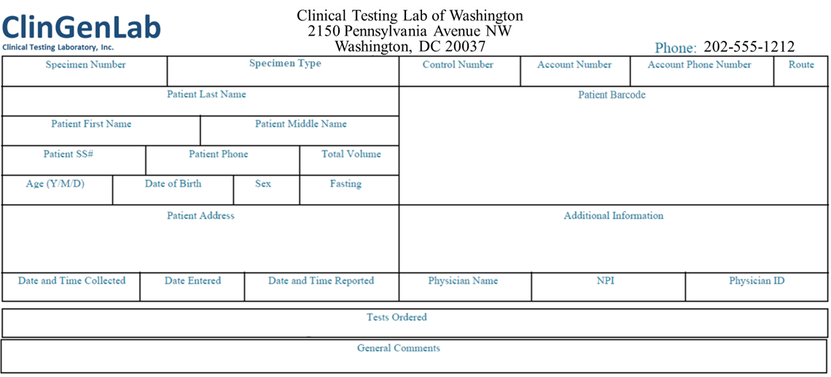 

**Clinical test results for Hyperinsulinism Evaluation**

| **TEST** | **RESULT** | **REFERENCE INTERVAL** |
| --- | --- | --- |
| Hgb A1c w eAG Estimation  Hemoglobin A1C  Please Note:  Pre-diabetes: 5.7 – 6.4  Diabetes: >6.4  Estim. Avg Glu (eAG) | 7.0%  154 mg/dL | 4.8 – 5.6  <117 mg/dL |

| **GENE** | **TEST RESULTS** | **EXPLANATION** |
| --- | --- | --- |
| PTPN1 (20q13.13) | Thr164= | Gene name: Protein Tyrosine Phosphatase Non-Receptor Type 1  **This result is inconclusive of Type 2 Diabetes.**  This result should be interpreted in the context of clinical presentation and results of other genetic tests.  A PCR/sequencing study has detected one copy of the Thr164 (PTPN1: c.492A>G or p.Thr164) variation. The Thr164 variation is an A to G change at nucleotide position 492 in the PTPN1 gene. This mutation encodes the same amino acid as the origin, so it does not impact the structure or function of the gene.  Thr164 is a silent mutation. This variation is benign and does not contribute to Type 2 diabetes. |
|  |  |  |
|  |  |  |
|  |  |  |
|  |  |  |
|  |  |  |
|  |  |  |
|  |  |  |
|  |  |  |